HTTP GET REQUEST packet (560 GET / HTTP/1.1 )

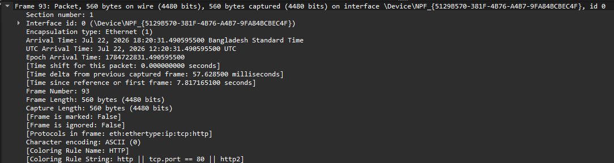
Here the Frame tells the properties of the packet that was captured. And here we can see the length of the frame is 560 bytes. Character encoding here is Ascii.
Is shows that the Source here is my computer(MicroStarINT) and the Destination is my router(DLinkInterna). Also their MAC address is being showed. With this MAC address hop to hop
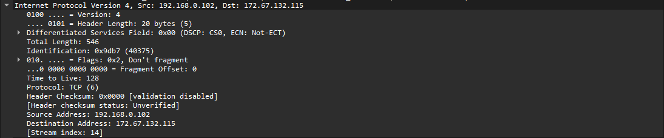
This provides the logical addressing of end to end devices where the source is my computer with its IP address(192.168.0.102) and Destination is the IP address of http://httpforever.com/ (172.67.132.115).
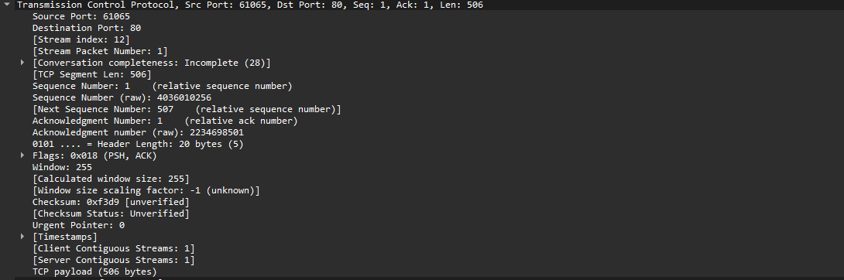
This is the TCP section where we can see the source port of my pc which is a dynamic/private port and destination port is a well known port.
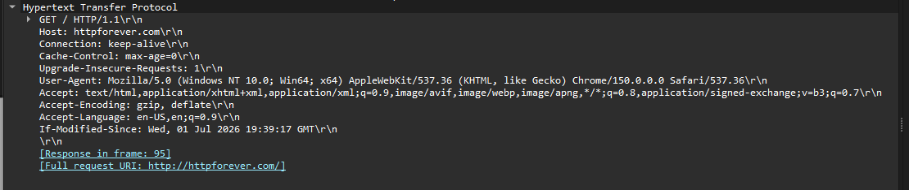
This is showing the GET method for requesting the main page form http://httpforever.com/

HTTP Response (60 HTTP/1.1 200 OK (text/html))

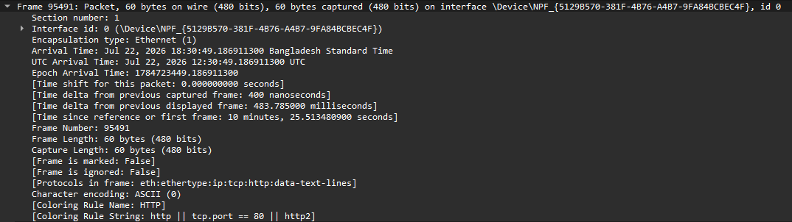This shows the frame properties of the incoming message. Where its length is 60 bytes. Time is shown when frame was captured along with encoding of character.
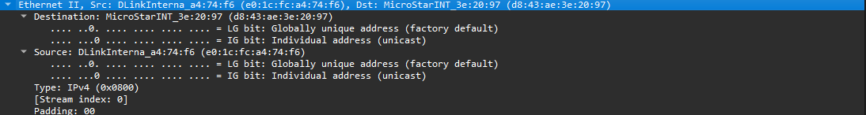
Here its reversed where now Source is the Router (DLinkInterna) along with its MAC address and Destination is our computer (MircoStarINT) and its MAC address
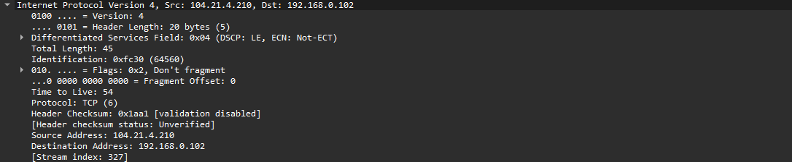
Also IP addresses is reversed here where the source is IP address of http://httpforever.com/ (104.21.4.210)) and Destination is my computer with its IP address(192.168.0.102).

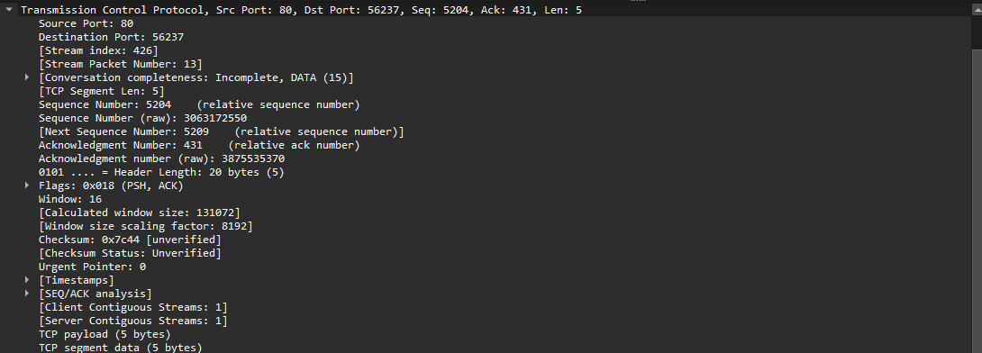
Here in TCP section its showing server is the Source port 80 sending information the our Computer of port 56237. Sequence number showing for reassembly window size is given laong with checksum for error detection.
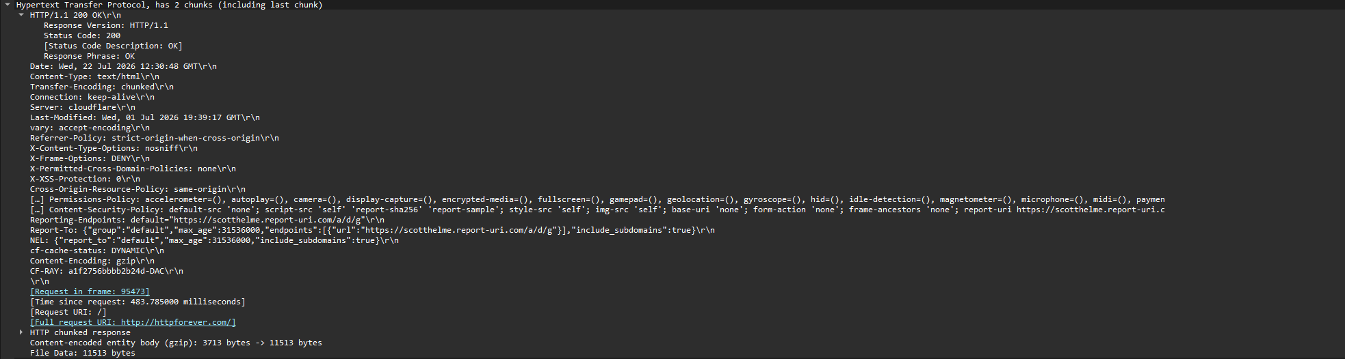
This is the site which shows the OK status 200 which confirms our request was successful along with the HTMP file which is 11513 bytes which my browser needs to read.

